*MARGINAL WORKERS FOR SOCIOECONOMIC ANALYSIS USING DATA ANALYTICS WITH COGNOS*

**Team member**

612721104060-M.MOHANRAJ

PROJECT SUBMISSION PHASE-2

PROJECT : MARGINAL WORKERS FOR SOCIOECONOMIC ANALYSIS

INTRODUCTION FOR MARGINAL WORKERS :



**Marginal workers, in the context of labour and employment, refer to individuals who are partially employed or underemployed, typically earning low wages and often working in the informal sector. These workers may not have regular employment or job security and may engage in temporary or seasonal work. The term “marginal workers” is often used in discussions about labour markets and workforce development to highlight issues related to income instability and job insecurity.**

**INTRODUCTION FOR SOCIOECONOMIC :**



Socioeconomic refers to the combination of social and economic factors that influence an individual's or a community's well-being and financial status. These factors can include income, education, employment opportunities, access to healthcare, housing, and more. Socioeconomic status often plays a significant role in determining a person's quality of life and opportunities available to them. It is a key consideration in many social and economic discussions and policies.

KEY WORDS :

MARGINAL EMPLOYMENT, MARGINAL LABOUR MARKET, MARGINAL WORKERS

POPULATION.

MARGINAL WORKERS CLASSIFIED BY AGE, INDUSTRIAL CATEGORY AND SEX :

**MARGINAL WORKERS:**

workers are those who work less than 6 months in a year. They are classified into four age groups:

•5-14

•15-34

•35-59

•60+

Marginal workers can be further classified by industrial category and sex . The industrial categories are:

•A: Agriculture, forestry, and fishing

•B:Mining and quarrying

•C:Manufacturing (processing and repair)

•D: Construction

•E:Wholesale and retail trade

•F:Transport, storage, and communication

•G:Finance, insurance, real estate, and business services

•H:Community, social, and personal services

•I: Activities not adequately defined

The following table shows the distribution of marginal workers by age, industrial category, and sex in India in 2011:

| Age group | Industrial category | Male | Female |

|  |  |  |  |
| --- | --- | --- | --- |
| AGE GROUP | INDUSTRIAL CATEGORY | MALE | FEMALE |

| 5-14 | A | 39,51,93 |41,06,918 |

| 15-34 | A | 10,56,09, |10,33,814 |

| 35-59 | A |10,09,44, |10,02,90,1 |

| 60+ | A | 6,37,09,204|6,46,44,418|

| 5-14 | B | 1,62,363 | 1,46,706 |

| 15-34 | B | 4,20,491 | 74,281 |

| 35-59 | B | 3,27,625 | 1,15,038 |

| 60+ | B | 3,85,842 | 1,23,696 |

| 5-14 | C | 2,06,200 | 2,02,759 |

| 15-34 | C | 11,43,844 | 5,73,876 |

| 35-59 | C | 15,28,214 | 7,28,359 |

| 60+ | C | 11,22,473 | 5,49,052 |

## https://docs.google.com/spreadsheets/d/19pklZLjSWqNgM4_r2wxPGNf2Xof6sgoY/edit?usp=drivesdk&ouid=109926994533499537960&rtpof=true&sd=true

As can be seen from the table, the majority of marginal workers are in the agriculture sector. This is followed by the manufacturing and construction sectors. There is also a significant number of marginal workers in the services sector, particularly in the community, social, and personal services category.

In terms of sex, the majority of marginal workers are female. This is because women are more likely to be involved in household and childcare activities, which can limit their ability to participate in the labour force.

It is important to note that the marginal worker population is not homogeneous. There is a great deal of variation in terms of their age, education, skills, and experience. Some marginal workers are unemployed for most of the year, while others work sporadically or part-time.

Marginal workers play an important role in the economy, even though they are often overlooked. They contribute to the production of goods and services, and they provide essential support services in their communities.

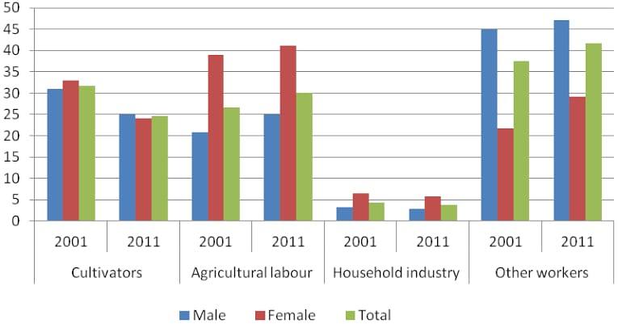

INNOVATION SOLUTION DESIGN AND IMPLEMENTATION PLAN

1.INTRODUCTION :

Briefly recap the challenges faced by marginal workers in Tamil Nadu and the need for an innovative socioeconomic solution.

**2.OBJECTIVES :**

Clearly define the objectives of the innovative solution, focusing on addressing socioeconomic issues faced by marginal workers.

3.DESIGN OVERVIEW :

A. INNOVATION FRAMEWORK ;

Present a high-level framework for the proposed solution, outlining key components and their interactions.

B. TECHNOLOGY INTEGRATION ;

Explain how technology will be leveraged to enhance the effectiveness and scalability of the solution.

4.DETAILED STEP FOR IMPLEMENTATION :

1. DATA COLLECTION AND ANALYSIS

1.IDENTIFY DATA SOURCES ;

- Specify the sources of socioeconomic data, including government databases, surveys, and field research

2.DATA PROCESSING AND CLEANSING ;

- Outline steps to process and cleanse raw data for accurate analysis.

3.STATISTICAL ANALYSIS ;

- Define statistical methods for extracting meaningful insights from the data.

1. STACKHOLDER ENGAGEMENT

1.IDENTIFY STACKHOLDERS ;

- List key stakeholders, including government agencies, NGOs, and local communities.

2.COMMUNITY INVOLVEMENT;

- Detail plans for involving local communities in the solution design and implementation.

1. INNOVATION INTEGRATION :

1.SOLLUTION PROTOTYPING ;

- Describe the process of developing a prototype for the innovative solution.

2.PILOT IMPLEMENTATION

- Outline the strategy for conducting a pilot program to test the solution's viability.

1. MONITORING AND EVALUATION:

1.PERFORMANCE METRICS ;

- Define metrics for evaluating the success of the solution.

2.FEEDBACK MECHANISM ;

- Establish a feedback mechanism to continuously improve the solution.

1. LEGAL AND ETHICAL CONSIDERATIONS :

1.COMPLIANCE ;

- Ensure that the solution aligns with legal and ethical standards.

2. PRIVACY PRODUCTION;

- Detail measures to protect the privacy of individuals involved.

5.TIMELINE :

Present a realistic timeline for the various phases of implementation, from data collection to full-scale deployment.

6.BUDGET :

Provide an estimated budget for implementing the proposed solution, including technology costs, personnel, and community engagement expenses.

7.RISK ANALYSIS :

Identify potential risks and challenges associated with the implementation and propose mitigation strategies.

8.CONCLUSION :

Summarize the innovative solution design and implementation plan, emphasizing its potential impact on improving the socioeconomic conditions of marginal workers in Tamil Nadu.

---

This document provides a comprehensive overview of the steps involved in transforming the design into an actionable plan. Adjustments can be made based on specific details and requirements.